

Documentation – February 2020

By Mahdee Al Mishkath, Lina Yusuf, Daniel Torres González,   
Timothy Ayoro Aaron, Dubo Graham-Douglas

# ABOUT PAGE

Protein phosphorylation is one of the most **important** regulatory mechanisms in animal cells. They play a predominant regulatory role in nearly every aspect of cell biology. With increasing research and emphasis on the kinase signalling network, there is a clear demand for easy to access kinase data. Our platform ‘pkinase’ was developed by a group of 5 students that are part of the MSc Bioinformatics Programme at Queen Mary University of London, under the supervision of Professor Conrad Bessant and Dr Fabrizio Smeraldi. The information we present to our users is all linked to a well curated database made from over 15 tables to provide the most accurate and robust information out there relating to kinases, phosphosites and inhibitors.

Contents

ABOUT PAGE 2

Software Architecture - 4

User Journey 5

Retrieving Data 5

Kinase Data 5

Inhibitor Data 6

Phosphosite Data 6

Data cleaning 6

Database construction and schema 6

Web development (Flask) 7

Web application design 7

Pkinase specifics 9

Kinase search 9

Inhibitor search 10

Phosphosite search 10

Phosphoproteomics upload tool 11

Running pkinase locally 12

Deploying the web application 13

Limitations 14

Future developments 14

Bibliography 15

# Software Architecture -

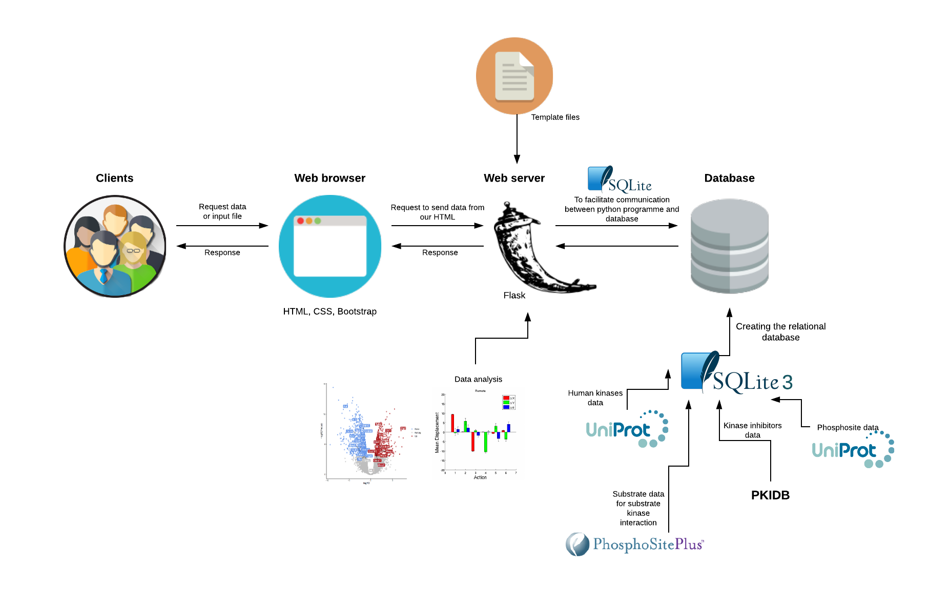

Figure - pkinase software architecture

The pkinase software architecture shown in figure 1 illustrates how the different components work together to produce the complete web application. The data we used for our site was retrieved from Uniprot, PKIDB and PhosphositePlus; this was then incorporated into a relational database using SQLite3. The python packages; sqlite and pandas were used to facilitate communication between the web server (Flask 1.1.1) and the database; the sqlite package was chosen as it is easy to use and it was convenient considering the database was also created using SQLite. Pandas was used to execute the sql queries; although it was not the quickest way, the queries were made as sql sentences, which are straightforward to write and understand, and are also very flexible. The web browser uses the HTML programming language to create the different pages shown on the website; bootstrap and CSS were used to design the layout of the site. As well as requesting information on kinases and inhibitors, the user can also input a file in order to receive a graphical summarisation of the file they have uploaded.

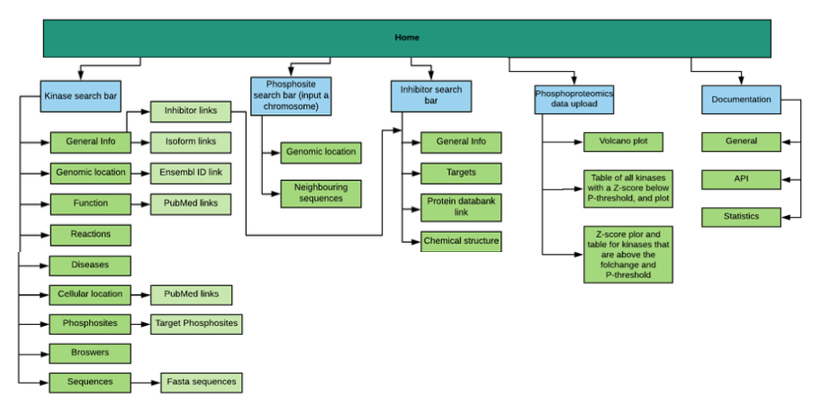User Journey **-**

Figure - pkinase site map illustrating the different web routes

Figure 2 provides an illustration of the different pathways that can be taken within the pkinase web application, it also shows how these web routes connect. The home page allows the user to search kinases, inhibitors and upload phosphoproteomic data; this page also has a dropdown labelled ‘Documentation’ which allows the user to find general information about the site, API and statistics.

Once a kinase or inhibitor has been searched, the user is directed to another page which will display information on the kinase/inhibitor. The results of a specific kinase search are displayed one page; and split into sections e.g. general information followed by genomic location in the next section of the page etc. Moreover, we have inserted the inhibitors that inhibit the users chosen kinase, into the kinase results page as a link; when clicked on, this link will transport the user to the page that displays all the information on that selected inhibitor.

Retrieving Data **–**

The data provided in our website comes from the following reputable sources: Uniprot, PKIDB, Ensembl and PhosphoSitePlus. Data retrieving was achieved using API services from both Uniprot and Ensembl. For this task, the Python libraries requests and bs4 (Beautiful Soup) were used to get and extract the needed information.

## Kinase Data

The Universal Protein Resource (UniProt), which provides a comprehensive collation of protein sequence and annotation data was used to obtain initial data for the Kinases found on our website. General information extracted from UniProt included a list of the human kinases, UniProt ids and kinase family (<https://www.uniprot.org/docs/pkinfam>). More information of each kinase was extracted from Uniprot API services (eg: <https://www.uniprot.org/uniprot/P31749.xml>, <https://www.ebi.ac.uk/proteins/api/coordinates?offset=0&size=100&accession=P31749>) such as protein function, associated diseases (i.e. disease name, effect text & disease description), isoforms, reactions, subcellular location, chromosome location, ensembl gene id, protein sequence, residue position and phosphosite modification type.

Using the Ensembl API (https://rest.ensembl.org/sequence/id/), we were able to retrieve genome starts, genome ends and the genome sequence for the genes that encode the kinases in our database. In the case of the genomic coordinates, both Uniprot and Ensembl report them however with different values, Ensembl information was preferred, due to the fact that they are specialized in gene-genomic information.

## Inhibitor Data

The inhibitor data for each kinase was gathered from a monthly updated Protein Kinase Inhibitor Database (PKIDB), which is a compilation of more than 200 inhibitors with annotations (<http://www.icoa.fr/pkidb/>). These compounds have been selected with a criterion of having a disclosed chemical structure, an International Non-proprietary Name (INN) and currently between phase 0 to phase 4 of clinical trials.

The data contained information on each of the inhibitors such as kinase family, PDBid, targets, image URLs, structural representations (INCHI and SMILES) as well as more refined properties (e.g. molecular weight). Since there were some inconsistencies (eg: repeated information) in the PKIDB, some data cleaning needed to be done.

## Phosphosite Data

Phosphosites information in our website combines information from Uniprot (genomic location of the phosphosites) and PhosphoSitePlus (https://www.phosphosite.org/homeAction.action). This last website provides a curated list of human phosphosites. In regards to our website, only human related data kinases-targets were retained. Relevant information such as UniProt ID for the kinases and substrates, modified position in the substrate, neighbouring sequence, and the sites of phosphorylation was obtained from this source. PhosphoSitePlus information was used as the primary input for the Phosphoproteomics analysis.

Data cleaning **–**

The data retrieved then had to be cleaned and formatted so that it was in a suitable condition for the database. This cleaning was done using python3, specifically, the pandas data analysis and manipulation tool was used as it is easier when dealing with tabular data. The cleaning consisted of removing repeats in the data, separating information that was found in one column into several columns, removing empty columns, getting rid of unwanted punctuation such as commas slashes, and also getting rid any unnecessary words.

Database construction and schema **–**

Whilst there are many relational database management systems (RDBMS) available such as oracle and MySQL, we decided to use SQLite3 for our database construction. This is due to its:

* Simplicity,
* Portability as it generates the ‘db’ file that can be stored locally thereby offsetting the need for servers (like those required by MySQL)
* Contents can easily be viewed using a variety of third-party tools like DB Browser for SQLite.

The information mined to be stored in the database was stored into separate CSV files, each covering a certain aspect of a kinase. As such, unique tables were created that correspond with the information stored in each CSV file and a schema was created to show how each table is making a relational link with other tables within the database (see figure 3). Upon creation of the database file with all (empty) tables made, the pandas package in python was utilised to import all csv’s to populate the empty tables.

The vast majority of tables relating to kinases were joined using Uniprot ID as the common foreign key, whilst the information relating to inhibitors were connected to each other using the inhibitor name (shown as ‘inn_name’ below). The choice to have our data distributed across multiple tables is due to the fact that much of our data has a one-to-many relationship whereby each kinase has hundreds of rows of usage information. As a result, it was deemed appropriate to split the data into separate tables to reduce duplication of information (as duplicate data wastes storage space and can make the database more difficult to maintain).

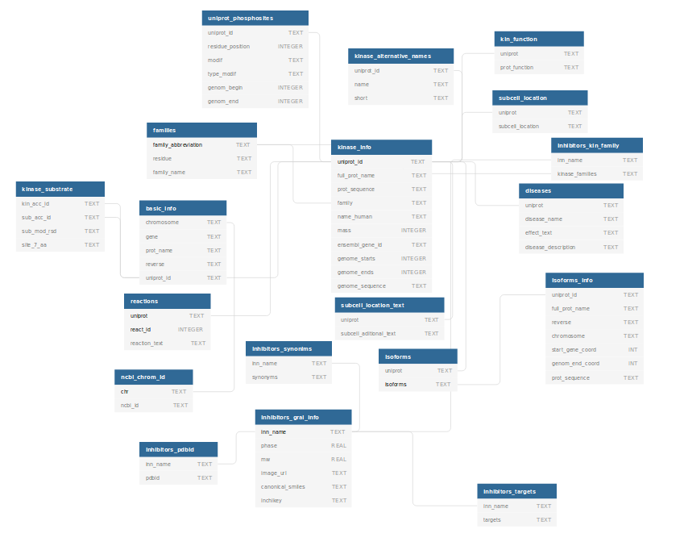

Figure - pkinase database schema tables relating to information about human inhibitors and kinases. The relational links between tables are indicated with arrows connecting the foreign key of one table to the primary key of another

A combination of SQL and pandas in python were used to execute queries in order to retrieve information from the database and read the results of a SQL query directly into a pandas data frame.

The retrieval of information from the database was facilitated through a combination of SQL and pandas in python whereby the ‘read_sql_query’ function in pandas reads the results of an SQL query directly into a pandas DataFrame. The advantage of doing so in this manner is that it automatically reads the names and headers from the table and creates the data frame for quick ease of exploration on the data. However, a key disadvantage encountered in doing so this way is that pandas does not persist data. For example, it even has a slow function called ‘to-sql’ that will persist your panda’s data frame to an RDBMs table.

Web development (Flask) **–**

Flask was used to build the web application. This micro-framework was chosen over other web-frameworks e.g. Django as it is easily operated. Flask allows for the smooth integration of different libraries such as jinja2; which is an engine for templates that was used in the development of pkinase, as well as wtforms to create the html forms and validators. Furthermore, for maintainability, blueprints were employed to allow for the splitting of different routes in separate python scripts. Flask is also easily incorporated into the html pages.

Web application design –

To define the various elements of pkinases’ web pages, HTML tags were applied. The bootstrap framework was chosen to make the responsive website; this framework ensures the website stays looking good regardless of the size of the window and if any changes are made to the screen (as shown by the images below). CSS was also used. The 12-grid system by bootstrap allows for the organisation of containers into specific rows and/or columns to fit the desired layout. These containers were employed to make features such as our search bars and buttons. A logo was inserted into our site by having the logo.png in a static folder, in the root directory. A favicon was also inserted to give pkinase a professional look.

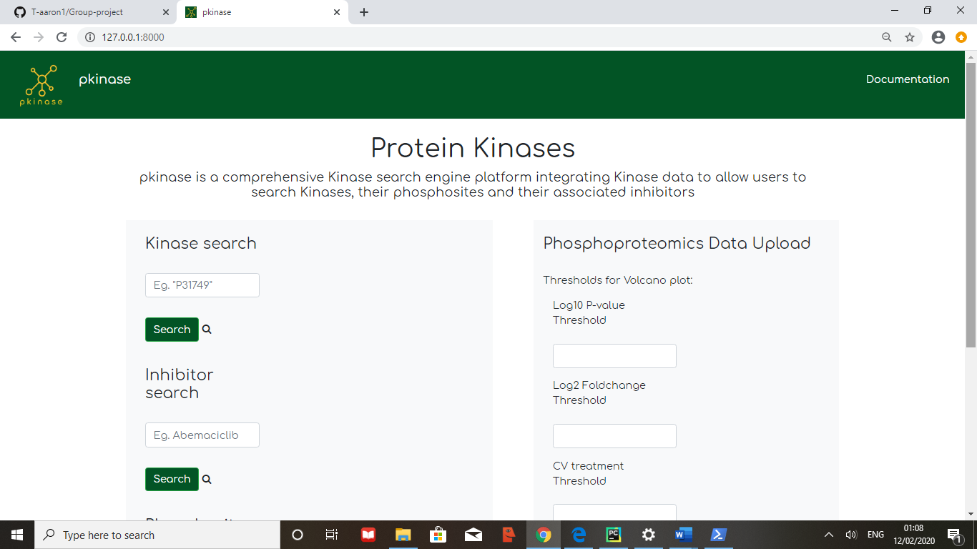

Figure - A snapshot of the pkinase web application full screen and landscape. This is how the site would look when viewed on a laptop/computer.

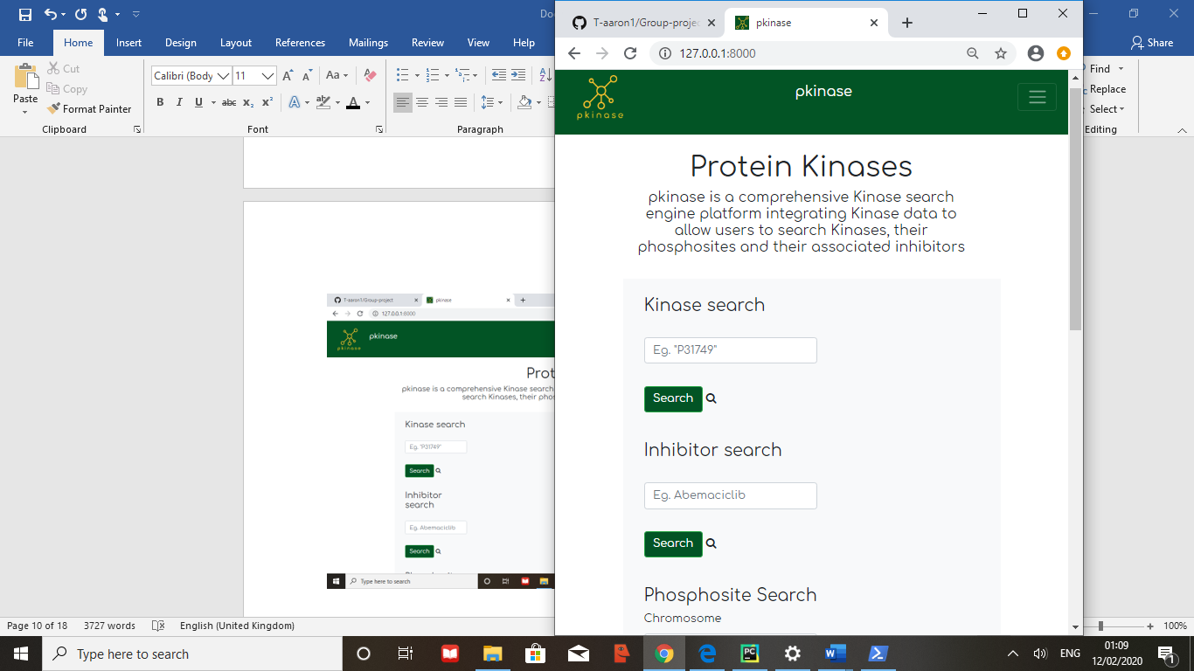

Figure - A snapshot of the pkinase web application when minimised, rather than side by side, the phosphoproteomics data upload is now under the Phosphosite search, everything is in one column. This is how the site would look if viewed on a phone.

Pkinase specifics **–**

## Kinase search

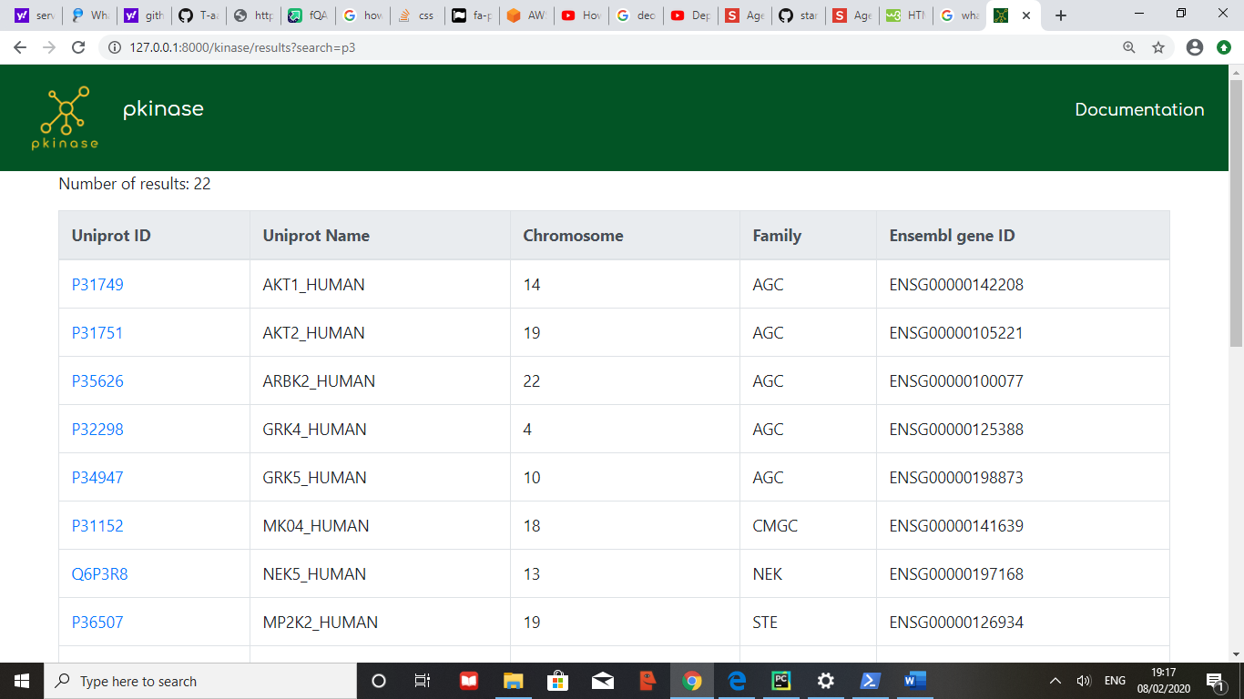Regarding the kinase search bar; the user can enter either the gene name or the Uniprot accession number, which is an alphanumeric identifier unique for each kinase. The kinase search bar also allows the user to enter a section of the Uniprot accession number e.g. ‘P3’; the web application will then output a table of all the kinases with ‘P3’ in their Uniprot ID (as shown in Figure 3). The user can then select which kinase they want to find out more information on; clicking on the Uniprot ID will direct them to the page for that specific kinase.

Figure - Shows a table of 8/22 kinases that have 'P3' in their Uniprot accession ID.

Once on the page for the specific protein kinase chosen; the user is able to find out all the information on that kinase. There are several sections to the kinase page, which are all listed in the side bar; clicking on the name of the desired section in the sidebar immediately directs the user to that part of the page, this is a favourable feature as it means the user doesn’t have to scroll down the whole kinase page to look for a specific piece of information.

The first section is ‘General information’; this includes the Uniprot ID, protein name, gene name, family name, mass and inhibitors associated with the kinase. The inhibitors have internal links to the specific inhibitor page, as well as this, the user also has the option of clicking on the small ‘i’ to find out a bit of information on that inhibitor e.g. the phase in clinical trials and the kinase families it affects.

We also decided to add isoforms into this section and internal links to the isoform protein fasta sequence; isoforms play significant roles in many biological processes; , in the case that the user may be researching this kinase for drug discovery purposes, we thought it would be beneficial to include these isoforms as they can also be employed as biomarkers of a disease state (Stastna and Van Eyk, 2012). This section also includes internal links to the protein and gene fasta sequences, as well as the JSON (JavaScript Object Notation) format which allows the user to store and transport data.

The second section of the kinase search results page is ‘Genomic location’; this section contains which chromosome the kinase is located on, the genomic location and an external link that transports the user to the Ensembl page for the specific kinase to find out more information.

The following sections are labelled ‘Function’, ‘Reaction’, ‘Diseases’ and ‘Cellular location’. The function section is beneficial to any user that may be researching this kinase to better understand a disease; for example, one function of the RAF1 protein kinase is to regulate proliferation and apoptosis (UniProt: a worldwide hub of protein knowledge, 2018), if this kinase happens to mutate, this could possibly lead to cancer. The function section also includes external PubMed links that transport the user to the article in which the function information was initially retrieved from. The reaction section allows the user to better understand how the kinase phosphorylates the target protein; for example

“ATP + L-seryl-[protein] = ADP + H(+) + O-phospho-L-seryl-[protein]” – (UniProt: a worldwide hub of protein knowledge, 2018)

This reaction shows that the target protein (L-seryl-[protein]) becomes phosphorylated by the kinase to form the product (+ O-phospho-L-seryl-[protein]).

The diseases section states the disease name, the aetiology, and a short description explaining what the disease is characterised by. This is useful to the user as it reinforces what can be learnt by looking at the functions section; the user can find out the consequences (what diseases occur) of a kinase malfunctioning.The sequence section provides the user with both the protein and gene sequences.

Regarding browsers, pkinase has a Uniprot ProtVista browser and an NCBI Genome Viewer. Uniprot protvista allows you to visualise the features that are identified in a protein sequence; this includes post-translational modifications (modified residues, glycosylation, disulphide bonds and cross-links), variants, Domains & sites (active site, binding site, nucleotide binding etc), sequence information and antigenic sequences. The NCBI viewer is orientated towards DNA, both browsers allow the user to gain access to information that is not displayed elsewhere on the site.

## Inhibitor search

The pkinase web application also features an inhibitor search bar; this search bar allows you to search for synonyms of an inhibitor, for example, the user could type in either ‘Abemaciclib’, ‘Verzenio’ or ‘LY-2835219’ and be transported to the same page. Once on the page, the information displayed includes the phase of clinical trials that the inhibitor is currently in. This is beneficial to the user as it informs them on whether or not the drug has been placed on the market yet, for example, Abemaciclib is in phase 4; this lets the user know that the drug has been approved by the appropriate authorities (FDA) and is currently being monitored for side effects (Cancer Research UK, 2020).

The inhibitor search results page also consists of the synonyms, molecular weight, the kinase family it affects and Canonical SMILES (Simplified Molecular Input Line Entry System); this gives the chemical structure a unique name. The InChIKey is also presented, this is the international chemical identifier for the inhibitor; the InChIKey format is particularly favourable for publishing metadata due to its short length and condensed form (www.InChI.info, 2020).

Users can also view an image of the chemical structure; this allows them to visualise the chemical bonds that make up the inhibitor. The Json format is also available as an internal link. Pkinase also exhibits the kinases the inhibitor targets as internal links; this interactivity between web routes allows the user to click on the target and be transported to the results page for that kinase to find out more information. Pkinase also provides an external link to the protein databank page for the specific inhibitor; this feature is useful if the user wants to find out more information that is not displayed on our site, for example, it shows the 3D chemical structure.

## Phosphosite search

As per the group briefing specification, we designed a search bar where users can browse phosphosites in terms of their genomic location (i.e. chromosome number, genome start and end coordinates).

The chromosome and genome start/end location search queries a search string against the kinase and phosphosite tables (see figure 7). This information will be used from the kinase table to output information linked to the uniprot id of the particular kinase in question from the phosphosite table (as the two tables are linked using the foreign key uniprot id). For instance, if chromosome ‘14’ is entered with genome start and & coordinates being ‘104769349’ and ‘104795751’ respectively, the output will be information linked to the uniprot id P31749 associated with that particular kinase from the phosphosite table (as this was the foreign key link between the kinase and phosphosite table). In addition we can also explore the neighbouring protein and DNA sequences nearby the phosphosite using the Uniprot ProtVista browser and an NCBI Genome Viewer.

Figure 7 – a snapshot depicting the result of a phosphosite search query of the kinase linked to the uniprot ‘P31749’ with chromosome entry being ‘14’ and genome start/end location being ‘104769349’’ & ‘104795751’ respectively. The output we see here is useful information regarding the position where phosphorylation takes place as well as the type of modification. We also can see information relating to neighbouring protein and DNA sequences.

## Phosphoproteomics upload tool

Our site can accept and process quantitative phosphoproteomics data in a tab-separated values file format (.tsv) only. The desired phosphoproteomics dataset to be uploaded on our site must be structured in a specific format. An example of an acceptable .tsv file structure can be found below:



Figure 8 - .tsv file structure, in this case 'AZD5438' is the specific inhibitor.

This should be presented with the columns arranged in the following order: Substrate, Control mean, inhibitor mean, fold change, p-value, control CV, inhibitor CV. If an incompatible file type is uploaded, an error message is displayed. The ‘Substrate’ Column accepts UniProtKB entry names and gene names.

Upon upload, the file is processed and converted to a dataframe as well as taking the name of the inhibitor and renaming the Inhibitor columns for further calculations. The name of the inhibitor is parsed through a query to display additional information about the chemical properties of the inhibitor/s used in the uploaded file. Data rows this null, ‘nan’ or ‘inf’ in the Inhibitor_fold_change column were removed from the dataset as it is impossible to infer a relative kinase activity score without values from this column. Substrate labelled with “_HUMAN” is converted to their gene names using Uniprot API for standardisation. The substrate column is split into 2 columns with one containing the gene name or uniprot ID and the other column containing the phosphorylation site. The Substrate columns which were unable to be converted by the Uniprot AP1 are parsed out of the data set as they are likely to be experimental proteins that do not have any phosphorylation sites in the dataset or Uniprot. Using the substrate name and the substrate phosphorylation site position this dataframe is then matched to the associated protein kinases at these specific sites, this was done using the Kinase-substrate dataset from ‘Phosphositeplus’. Once matched the file is then converted to a dataframe to calculate the relative kinase activity and produce visualisation plots.

Using the KSEA (Kinase Substrate Enrichment Analysis) formula allows our site computationally to infer relative kinase activity from quantitative phosphoproteomics data & have it summarised graphically. Scores are generated for each kinase according to the relative hyper-phosphorylation or dephosphorylation of the majority of its substrates. With this score, we can determine the overall activity for each kinase relative to the control and obtain statistical P-values from the uploaded file to create an interactive graphical analysis of the dataset. More information about the scoring system can be found in

<https://academic.oup.com/bioinformatics/article/33/21/3489/3892392>

Below is a table explaining how the columns in the output table are formulated:

|  |  |
| --- | --- |
| Kinase | The identified Kinase which is either phosphorylated or hyper-phosphorylated |
| Z-Score | The Z-score was calculated by finding the mean log2(Fold change) of known phosphosites for a given kinase minus the mean log2(Fold change) for all phosphosite in the dataset. Multiplied by the square root of the total number of phosphosite substrates identified from the sample that annotate to the specified kinase, divided by the standard deviation of the log2(fold change) across all phosphosites in the data set. |
| P-value | The P-value is determined by assessing the one-tailed probability of having a more extreme score than the one measured. |

For visualisation of the significant substrate molecules against fold change, a volcano plot was produced using Plotly for interactive visualization. At the upload page, the user can enter the fold change, p-value and coefficient of variance and background noise thresholds to customise the display of the results. With the fold change threshold parameter, the user can define values below which they consider to be inhibited. With p-values, users can define the p-value threshold. Values above the threshold will be coloured grey in the volcano plots and filtered out from the results table. Data with a coefficient of variation values above the user-set threshold are filtered out. With the background noise parameter, user can define values below which they consider to be noise or insignificant low-level phosphorylation. The log transformation was performed on fold change and p-values where the volcano plots show log2 fold change (x-axis) plotted against log10 p-value.

Additionally, a Z-score barplot was used to visualise the relative kinase activity of a given inhibitor along with a table to accompany this information. A second Z-score plot was also included which is produced from the above threshold substrates in the volcano plot user input.

Running pkinase locally **–**

***Instructions:***

mkdir group_proj

cd group_proj

python3 -m venv venv

cd venv

mkdir src #this is where you will find all the python code

cd src

***Inside src directory: install requirements***

***Step 1 – activate the virtual environment:***

source bin/activate

***Step 2 – Clone the repository inside src:***

git clone https://github.com/T-aaron1/Group-project

***Step 3 – Install required packages:***

pip install --upgrade pip pip install -r requirements.txt

***starting the development server -***

***go into the flask directory:***

python flask_script.py

* Running on <http://127.0.0.1:8000/>

Deploying the web application **–**

The chosen method of deployment for our platform was Amazon Web Services (AWS) Elastic Beanstalk. This service allows for quick deployment of an application using the AWS Cloud all the while supporting applications that used an array of languages such as Python, Ruby, Java and PHP. Fortunately, Elastic Beanstalk handles the major workings of the deployment including the details of capacity provisioning, load balancing, scaling, and application health monitoring.

It was crucial to follow the Instructions and once the application was deployed, Elastic Beanstalk can show the health status of the webserver. At first, we encountered an issue of failure to deploy and so our app script was changed from flask_script.py to application.py. This is the default option, and you can change it by modifying the WSGIPath in the root of your app folder. In the application.py file, the WSGI will look for an application object, therefore, it is strongly recommended you assign your Flask app to application, with the following line have application assigned to app. This extra line of code is simple and further resolves the issue of having to rename any object to application within the file.

We also included a requirements.txt file to make elastic beanstalk knows which packages to load into the newly made virtual environment. First, we installed the ‘pip freeze’ package, using the following command “pip freeze”, executed in our terminal. With pip freeze installed, we simply run the pip freeze command to generate requirements.txt file

In the final stages of deployment, we compressed our file contents into a zip file. This zip is then simply uploaded to elastic beanstalk, which then takes care of the rest and will deploy the application. However, Elastic Beanstalk does currently suffer limited clarity in its documentation.

This meant we encountered many unique errors which required a process of trial and error in order to successfully deploy our application.

The link to our deployed version is shown below:

<http://test-env-1.a52w5zpuqi.us-east-2.elasticbeanstalk.com/>

Limitations **–**

One identified limitation is that advancements in clinical trial phases are not automatically updated as the database would have to be edited after any changes in trial phase.

When more than one inhibitor is present in the uploaded file for the phosphoproteomic analysis the process of producing the visualisation takes a while to render the page ( 8 inhibitors takes around 50 secs), due to this extended length of time we opted not to do a volcano plot visualisation when there is more than 1 inhibitor. This is due to the plotly CDN limitation which significantly slows down the process. Furthermore, since we are only using UniProt API to identify gene names and proteins, the tool might miss other synonyms and alternative names that can’t be queried with UniProt.

One limitation of the deployment of the website involved an error with the ‘import scipy’ in the requirements file, this package was not compatible with the amazon beanstalk deployment program. This particular issue greatly pushed our time constraints as we had to change our code to calculate the P-value in a different way.

Future developments **–**

We could possibly create add a page where the user can insert a protein or gene fasta sequence, and have the web application output the protein kinases that are most closely related.

A technical aspect we had considered if granted more time was to implement a more advanced interactive viewer whereby the software could generate a full kinase interaction network of all known kinases. This would arguably rival a similar software package, popularly known as Cytoscape where we would intend to show how the user could explore the network whether it be selecting specific nodes and seeing surrounding first neighbours or seeing the two most distant nodes within the network. To achieve this, the python package NetworkX would be used. We believe in doing so that it would allow the user to enhance their understanding of the phosphorylation network.

In addition, we at pkinase anticipate discoveries of new kinases and inhibitors in the near future. Therefore, upon accreditation and thorough publication checks, we believe it would it be in the best interests of the scientific community if our users can themselves add to our growing database such as by uploading their own files for data analysis. This would ensure our database is up to date, providing the most accurate account of information of kinases/inhibitors within the field of phosphoproteomics. Our main aim is to have this platform to be user driven and be the leading tool in kinase/inhibitor search

Bibliography **–**

Cancer Research UK. (2020). *Phases of clinical trials*. [online] Available at: https://www.cancerresearchuk.org/about-cancer/find-a-clinical-trial/what-clinical-trials-are/phases-of-clinical-trials#phase4 [Accessed 10 Feb. 2020].

Carles, F., Bourg, S., Meyer, C. and Bonnet, P. (2018). PKIDB: A Curated, Annotated and Updated Database of Protein Kinase Inhibitors in Clinical Trials. *Molecules*, 23(4), p.908.

Flask.palletsprojects.com. (2020). *Welcome to Flask — Flask Documentation (1.1.x)*. [online] Available at: https://flask.palletsprojects.com/en/1.1.x/ [Accessed 11 Feb. 2020].

Getbootstrap.com. (2015). *Getting started · Bootstrap*. [online] Available at: <http://getbootstrap.com/getting-started/#support>

Hipp, R, et. al. (2015). SQLite (Version 3.8.10.2) [Computer software]. SQLite Development Team.

H.M. Berman, J. Westbrook, Z. Feng, G. Gilliland, T.N. Bhat, H. Weissig, I.N. Shindyalov, P.E. Bourne.  
(2000) The Protein Data Bank [*Nucleic Acids Research*, 28: 235-242.](http://dx.doi.org/10.1093/nar/28.1.235)

Howe, K., Contreras-Moreira, B., De Silva, N., Maslen, G., Akanni, W., Allen, J., Alvarez-Jarreta, J., Barba, M., Bolser, D., Cambell, L., Carbajo, M., Chakiachvili, M., Christensen, M., Cummins, C., Cuzick, A., Davis, P., Fexova, S., Gall, A., George, N., Gil, L., Gupta, P., Hammond-Kosack, K., Haskell, E., Hunt, S., Jaiswal, P., Janacek, S., Kersey, P., Langridge, N., Maheswari, U., Maurel, T., McDowall, M., Moore, B., Muffato, M., Naamati, G., Naithani, S., Olson, A., Papatheodorou, I., Patricio, M., Paulini, M., Pedro, H., Perry, E., Preece, J., Rosello, M., Russell, M., Sitnik, V., Staines, D., Stein, J., Tello-Ruiz, M., Trevanion, S., Urban, M., Wei, S., Ware, D., Williams, G., Yates, A. and Flicek, P. (2019). Ensembl Genomes 2020—enabling non-vertebrate genomic research. *Nucleic Acids Research*, 48(D1), pp.D689-D695.

McKinney, W., & others. (2010). Data structures for statistical computing in python. In *Proceedings of the 9th Python in Science Conference* (Vol. 445, pp. 51–56).

Richardson, L. (2007). Beautiful soup documentation. *April*.

Stastna, M. and Van Eyk, J. (2012). Analysis of protein isoforms: Can we do it better?. *PROTEOMICS*, 12(19-20), pp.2937-2948.

UniProt: a worldwide hub of protein knowledge. (2018). *Nucleic Acids Research*, 47(D1), pp.D506-D515.

Wiredja, D., Koyutürk, M. and Chance, M. (2017). The KSEA App: a web-based tool for kinase activity inference from quantitative phosphoproteomics. *Bioinformatics*, 33(21), pp.3489-3491.

www.InChI.info. (2020). *InChIKey - www.InChI.info*. [online] Available at: https://inchi.info/inchikey_overview_en.html [Accessed 10 Feb. 2020].